Association Rule Learning: Eclat Intuition

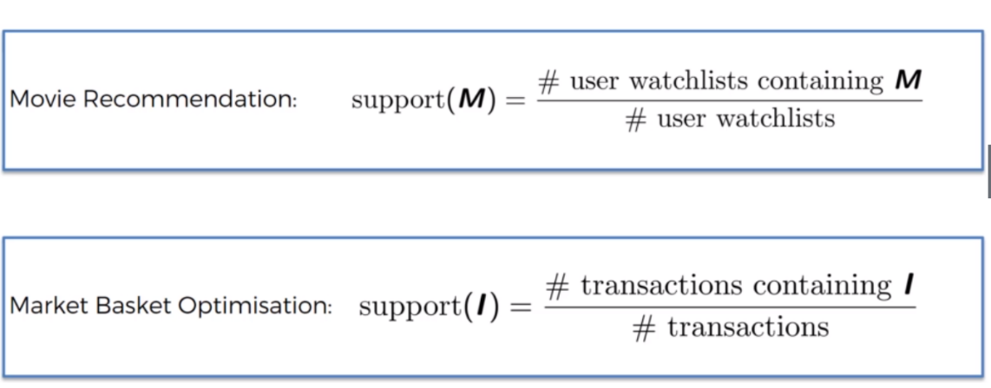People who bought also bought.. to find the potential Rules.

Step 1: Set a minimum support

Step 2: Take all the subsets in transactions having higher support than minimum support

Step 3: Sort these subsets by decreasing support